Lab: Heaps and BST
This document defines the lab for "Data Structures – Fundamentals (Java)" course @ Software University. Please submit your solutions (source code) of all below described problems in Judge.
Write Java code for solving the tasks on the following pages. Code should compile under the Java 8 and above standards you can write and locally test your solution with the Java 13 standard, however Judge will run the submission with Java 10 JRE. Avoid submissions with features included after Java 10 release doing otherwise will result in compile time error.
Any code files that are part of the task are provided as Skeleton. In the beginning import the project skeleton, do not change any of the interfaces or classes provided. You are free to add additional logic in form of methods in both interfaces and implementations you are not allowed to delete or remove any of the code provided. Do not change the names of the files as they are part of the tests logic. Do not change the packages or move any of the files provided inside the skeleton if you have to add new file add it in the same package of usage.
Some tests may be provided within the skeleton – use those for local testing and debugging, however there is no guarantee that there are no hidden tests added inside Judge.
Please follow the exact instructions on uploading the solutions for each task. Submit as .zip archive the files contained inside "...\src\main\java" folder this should work for all tasks regardless of current DS implementation.
In order for the solution to compile the tests successfully the project must have single Main.java file containing single public static void main(String[] args) method even empty one within the Main class.
Some of the problem will have simple Benchmark tests inside the skeleton. You can try to run those with different values and different implementations in order to observe behaviour. However keep in mind that the result comes only as numbers and this data may be misleading in some situations. Also the tests are not started from the command prompt which may influence the accuracy of the results. Those tests are only added as an example of different data structures performance on their common operations.
The Benchmark tool we are using is JMH (Java Microbenchmark Harness) and that is Java harness for building, running, and analyzing, nano/micro/milli/macro benchmarks written in Java and other languages targeting, the JVM.
Additional information can be found here: JMH and also there are other examples over the internet.
Important: when importing the skeleton select import project and then select from maven module, this way any following dependencies will be automatically resolved. The project has NO default version of JDK so after the import you may (depends on some configurations) need to specify the SDK, you can download JDK 13 from HERE.

Binary Tree

Inside the given skeleton. You should implement the BinaryTree<E> class with the following operations:
- E getKey() – returns the key of a node
- AbstractBinaryTree<E> getLeft() – returns the left sub tree of a node
- AbstractBinaryTree<E> getRight() – returns the left right tree of a node
- void setKey(E key) – sets the key of a node
- String asIndentedPreOrder(int indent) – returns the tree as String each inner level is idented with 2 spaces as padding
- List<AbstractBinaryTree<E>> preOrder() – returns the tree in preOrder – first we add the visiting node then we continue with the left and right child
- List<AbstractBinaryTree<E>> inOrder() – returns the tree in inOrder – first we move left as much as we can then add the visiting node and then we continue the right child
- List<AbstractBinaryTree<E>> postOrder() – returns the tree in postOrder – first we move left, then right and at the end as we have no path, we add the visiting node
- void forEachInOrder(Consumer<E> consumer) – applies a Consumer<E> on each node traversed inOrder

Examples
Look at the provided tests inside the skeleton.
This problem is really a lot like DFS or BFS we already know how to solve. With a little twist we can reuse recurrence and solve all of them, think about the definition which action is before the next one and the other way around etc…
Hints:
There are of course hints inside the presentation if you are stuck somewhere.

MaxHeap

Inside the given skeleton. You should implement the MaxHeap<E> class with the following operations:
- int size() – returns the number of elements in the structure
- void add(E element) – adds an element
- E peek() – returns the maximum element without removing it
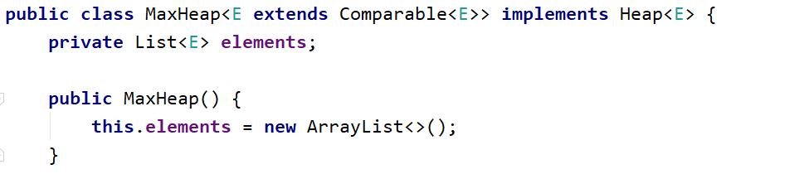

Examples
Look at the provided tests inside the skeleton.

Peek
In a max heap, the max element should always stay at index 0. Peek should return that element, without removing it. Verify that the structure is not empty, otherwise throw IllegalStateException with some message.
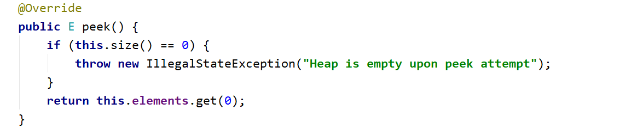

Add
Adding an element should put it at the end and then bubble it up to its correct position. HeapifyUp receives as a parameter the index of the element that will bubble up towards the top of the pile.
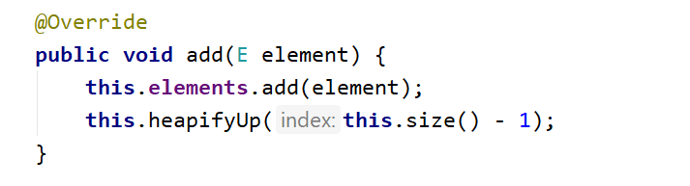
Time to implement HeapifyUp. While the index is greater than 0 (the element has a parent) and is greater than its parent, swap child with parent. Implement the helper methods (parent() and less()) by yourself.
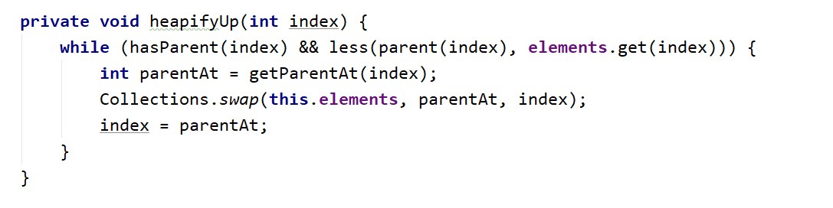

PriorityQueue

Inside the given skeleton. You should implement the MaxHeap<E> class with the following operations:
- int size() – returns the number of elements in the structure
- void add(E element) – adds an element
- E peek() – returns the maximum element without removing it
- E poll() – returns the maximum element and removes it

Examples
Look at the provided tests inside the skeleton.
Add, Peek and Size
How different are those methods to the once implemented for the MaxHeap problem? Can you reuse those methods?
Poll
In a PriorityQueue, the max element should always stay at index 0. Peek should return that element, and remove it. Verify that the structure is not empty, otherwise throw IllegalStateException with some message.
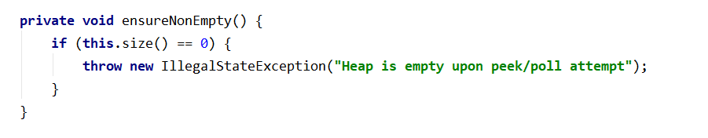
Next, we need to save the element on the top of the heap (index 0), swap the first and last elements, exclude the last element and demote the one at the top until it has correct position
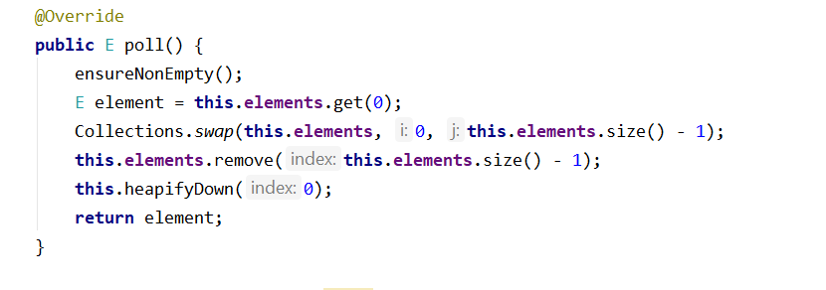
The HeapifyDown() function will demote the element at a given index until it has no children or it is greater than its both children. The first check will be our loop condition
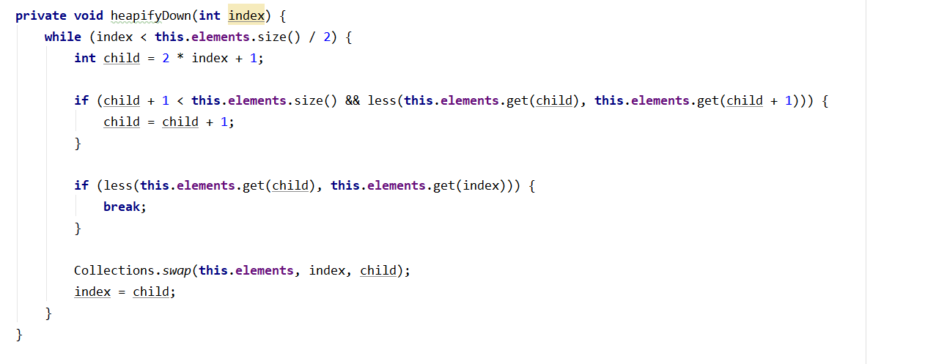

Binary Search Tree (BST)

Inside the given skeleton. You should implement the BinarySearchTree<E> class with the following operations:
- void insert(E element) – adds an element
- boolean contains(E element) – returns the maximum element without removing it
- AbstractBinarySearchTree<E> search(E element) – returns the tree with given element value as root if exists if not return empty tree
- Node<E> getRoot() – returns the root of a tree
- Node<E> getLeft() – returns the leftChildren of a tree node
- Node<E> getRight() – returns the rightChildren of a tree node
- E getValue() – returns the value of a tree node

Examples
Look at the provided tests inside the skeleton.
This time you have to solve the problem on your own. Think about it we know all we need to so far. It is pretty simple. Use the tests provided and create new test cases for debugging and code correctness validation.
Hints:
There are of course hints inside the presentation if you are stuck somewhere.

"Somewhere, something incredible is waiting to be known."
― Carl Sagan

